DATA SCIENCE TOOLBOX: PYTHON PROGRAMMING
PROJECT REPORT
(Project Semester January-April 2025)

"Comprehensive Analysis of COVID-19 Mortality Trends in the U.S."

Submitted by: Gaurav Bhatnagar

Registration No: 12303832
ROLL No: 54

Section K23SG
Course Code INT375

Under the Guidance of

(Dr. Manpreet Singh Sehgal)

Discipline of CSE/IT

Lovely School of Computer Science & Engineering
Lovely Professional University, Phagwara
CERTIFICATE

This is to certify that Gaurav Bhatnagar bearing Registration no.12303832 has completed INT375 project titled, “COVID-19 Mortality Trends in the U.S."” under my guidance and supervision. To the best of my knowledge, the present work is the result of his/her original development, effort and study.

Signature and Name of the Supervisor
Designation of the Supervisor
School of Computer science & Engineering
Lovely Professional University
Phagwara, Punjab.

Date: 11 April 2025

DECLARATION

I, Gaurav Bhatnagar student of Computer science & engineering under CSE/IT Discipline at, Lovely Professional University, Punjab, hereby declare that all the information furnished in this project report is based on my own intensive work and is genuine.

Date: 11 April 2025 Signature:

Registration No. 12303832 Name of the student: Gaurav Bhatnagar

Acknowledgement

I would like to express my sincere gratitude to my faculty, Dr. Manpreet Singh Sehgal, for his continuous guidance, valuable feedback, and consistent support throughout this project.
I would also like to thank Lovely Professional University for providing the resources and academic environment that allowed me to complete this project successfully.
Last but not least, I extend my thanks to my friends for their encouragement and support during the course of this work.

Gaurav Bhatnagar

Table Of Content
1. Introduction
2. Source of dataset
3. EDA process
4. Analysis on dataset (for each analysis)
I. Introduction
ii.General Description
iii.Specific Requirements, functions and formulas
iv.Analysis results
v.Visualization
5. Conclusion
6. Future scope
7. References

LinkedIn Post

https://www.linkedin.com/posts/gaurav-bhatnagar-8b6a76288_datascience-python-eda-activity-7316753475898339328-1Sis?utm_source=share&utm_medium=member_desktop&rcm=ACoAAEXs3IoBL3y186ctQW5sEfbDo5Gp5muZgvw

GitHub Link
https://github.com/Gaurav-Bhatnagar-29/Project

1. Introduction
The COVID-19 pandemic has had an unprecedented impact on global health, economies, and daily life. One of the most critical aspects of understanding the scope of the pandemic is analyzing mortality data to identify trends and demographic factors associated with higher death rates. This report utilizes the dataset titled "Provisional COVID-19 Deaths by Sex and Age" to conduct a comprehensive statistical analysis. By exploring various aspects such as sex, age group, and geographic location, we aim to derive insights that can inform public health responses and policy decisions. This report also highlights key analytical techniques used in examining the dataset, with relevant visualizations and discussions.
2. Source of Dataset
The dataset used in this report is titled "Provisional COVID-19 Deaths by Sex and Age", compiled and published by the Centers for Disease Control and Prevention (CDC). It includes provisional counts of deaths involving COVID-19 and other related causes. The dataset spans from January 1, 2020, to September 23, 2023, and includes a total of 137,700 records.
Source Link: https://catalog.data.gov/dataset/provisional-covid-19-death-counts-by-sex-age-and-state

Each record contains information on:
- Time period (Start Date and End Date)
- Location (State)
- Demographics (Sex and Age Group)
- Number of deaths attributed to COVID-19, pneumonia, and influenza
- Combined categories (e.g., Pneumonia and COVID-19)
This data serves as the foundation for all analyses conducted in this report.

3. EDA Process
Before conducting detailed analysis, an Exploratory Data Analysis (EDA) process was performed to clean and understand the dataset. The key steps in this process included:
- Data Cleaning:
  - Handled missing values in Month and Year columns.
  - Removed or flagged entries with missing COVID-19 Deaths or Total Deaths.
- Data Type Conversion:
  - Dates were converted to datetime objects.
  - Numerical columns were converted to float or integer types as appropriate.
- Filtering Irrelevant Data:
  - Excluded aggregated data (e.g., entries for "All Ages" or "All Sexes") where detailed analysis was required.
- Summary Statistics:
  - Total deaths, average deaths per month, and trends by sex and age group were calculated.
- Grouping:
  - Data was grouped by State, Age Group, and Sex for comparative analysis.
This EDA phase ensured that the dataset was prepared and ready for meaningful analytical procedures.

4. Analysis on Dataset

4.1 COVID-19 Deaths by Age Group and Sex
i. Introduction: Understanding the distribution of COVID-19 deaths by age and sex can highlight vulnerable populations.
ii. General Description: The dataset segments deaths by detailed age groups and sex categories (Male, Female).
iii. Specific Requirements, Functions, and Formulas:
- Grouped data by Age Group and Sex
- Aggregated the number of COVID-19 Deaths
iv. Analysis Results:
- The death rate was significantly higher in older age groups, especially those 65 years and older.
- Among all age groups, males had a consistently higher number of deaths than females.
v. Visualization:
- Clustered bar chart for COVID-19 deaths by age and sex
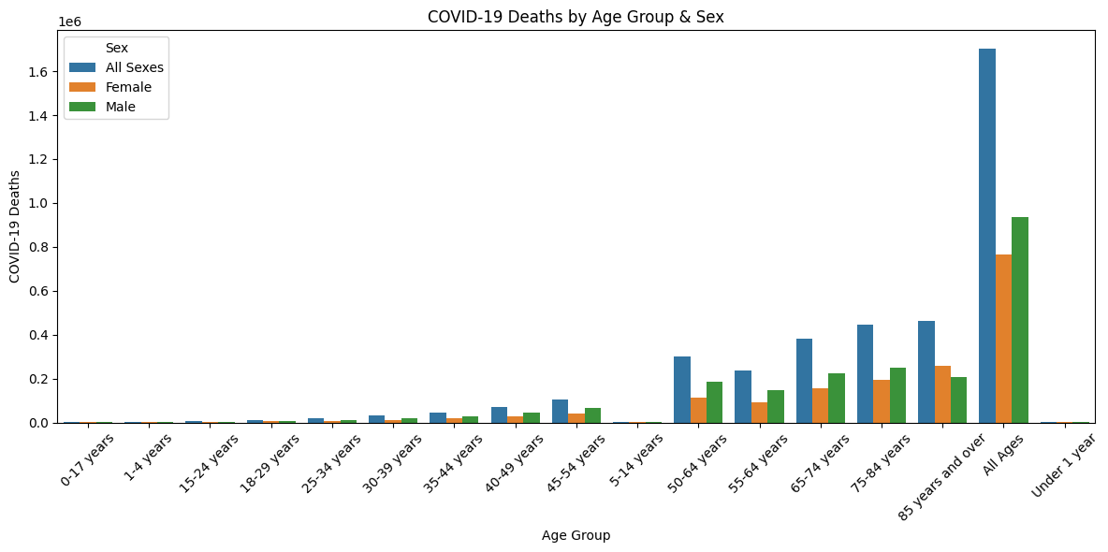

4.2 Total COVID-19 Deaths by Sex
i. Introduction: A breakdown by sex shows which gender was more affected overall.
ii. General Description: The dataset allows filtering by Sex to determine total COVID-19 deaths for males and females.
iii. Specific Requirements, Functions, and Formulas:
- Summed COVID-19 Deaths grouped by Sex
iv. Analysis Results:
- Males accounted for slightly more COVID-19 deaths than females.
v. Visualization:
- Pie chart showing death proportions by sex
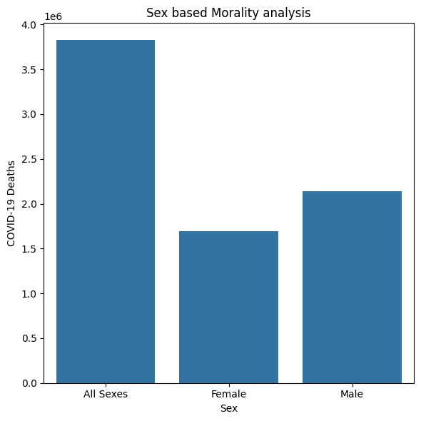

4.3 Correlation Between COVID-19 and Respiratory Deaths
i. Introduction: Many COVID-19 patients also suffered from other respiratory conditions such as pneumonia.
ii. General Description: The dataset includes columns for pneumonia, influenza, and combined respiratory deaths.
iii. Specific Requirements, Functions, and Formulas:
- Calculated correlation coefficients between COVID-19 Deaths and Pneumonia Deaths, Influenza Deaths, and combined causes.
iv. Analysis Results:
- Strong positive correlation was observed between COVID-19 and pneumonia deaths, indicating frequent comorbidity.
v. Visualization:
- Scatter plots with trend lines
- Correlation heatmap
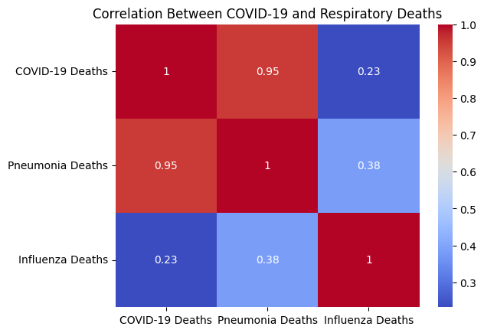

4.4 Top States with Highest COVID-19 Deaths by Month
i. Introduction: This analysis helps identify regional spikes in mortality over time.
ii. General Description: Data was grouped by Month and State to identify top contributors.
iii. Specific Requirements, Functions, and Formulas:
- Used monthly aggregation of COVID-19 deaths by state
- Extracted top 5 states per month
iv. Analysis Results:
- States like New York, California, and Texas appeared frequently as top contributors during peak waves.
v. Visualization:
- Line chart with separate lines per top state
- Animated or stacked monthly bar chart
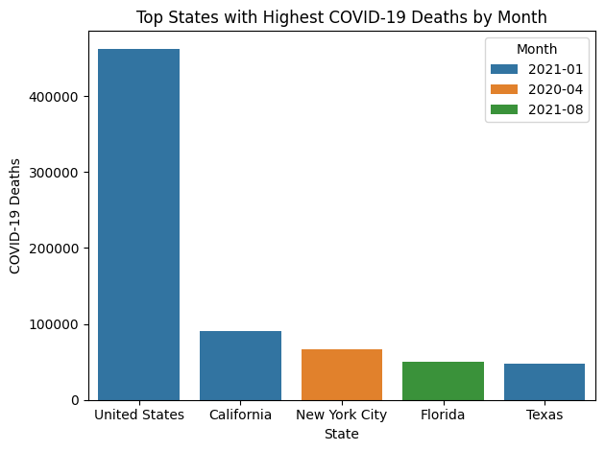

4.5 Average COVID Deaths as % of Total Deaths by State
i. Introduction: This metric offers insight into the relative impact of COVID-19 within state-level death counts.
ii. General Description: Percentage of COVID-19 deaths to total deaths was calculated per state.
iii. Specific Requirements, Functions, and Formulas:
- (Sum of COVID-19 Deaths / Sum of Total Deaths) * 100 grouped by State
iv. Analysis Results:
- Some states had COVID-19 accounting for more than 20% of all deaths during peak periods.
v. Visualization:
- Choropleth map of the US
- Bar chart showing percentages by state
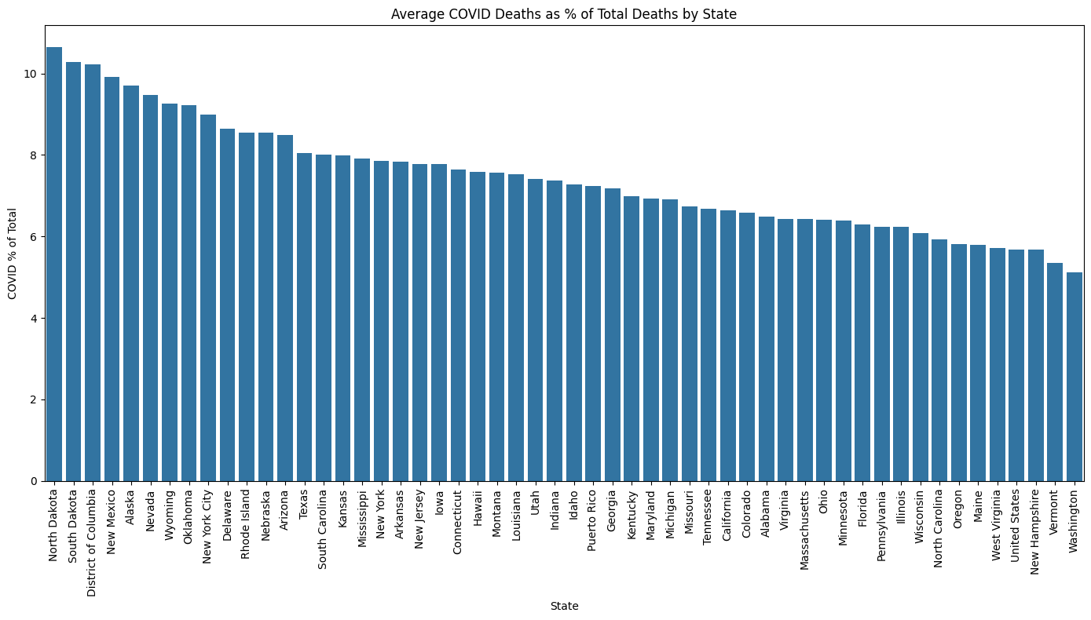

5. Conclusion
The analysis of the COVID-19 mortality dataset revealed crucial insights:
- Older adults, particularly those aged 65 and above, faced the highest mortality.
- Males were more likely to succumb to the disease compared to females.
- There was a strong relationship between COVID-19 and other respiratory illnesses.
- States such as California, New York, and Texas experienced the highest numbers of COVID-related deaths.
- Some states saw COVID-19 account for a significant proportion of total deaths.
6. Future Scope
The dataset opens several avenues for extended research:
- Incorporating population data for normalized per capita death analysis
- Time series forecasting using ARIMA or other models
- Regional policy impact analysis by comparing state regulations with death trends
- Analyzing vaccination rates alongside death trends
7. References

- NYC Open Data Portal
https://opendata.cityofnewyork.us
(Primary source for Civil Service List dataset)
- Pandas Documentation
https://pandas.pydata.org/docs
- Matplotlib Documentation
https://matplotlib.org/stable/contents.html
- Seaborn Documentation
https://seaborn.pydata.org
- Scikit-learn (For potential future modeling)
https://scikit-learn.org/stable/

